**How to build the kiosk app**

This is the structure of the kiosk app, it contains bower.json, and gulpfile.js. You have to install bower_components and node_modules.

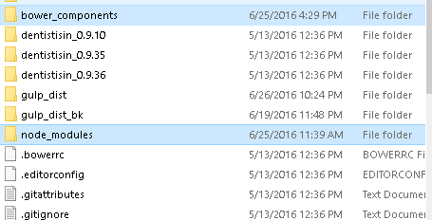

1. install nodejs

<http://blog.teamtreehouse.com/install-node-js-npm-windows>

1. install node_modules

* open Node.js command promt
* using command: **npm install**

Note: Install related package if missing. Example**:** cannot find module ‘**gulp-ng-annotate'**. Refer to link: <https://www.npmjs.com/package/gulp-ng-annotate>

1. install bower_components

<https://bower.io/>

* using command: **npm install -g bower**

1. install grunt

<http://gruntjs.com/installing-grunt>

**npm install grunt@VERSION --save-dev**

1. modify css by using sass command to build main.css

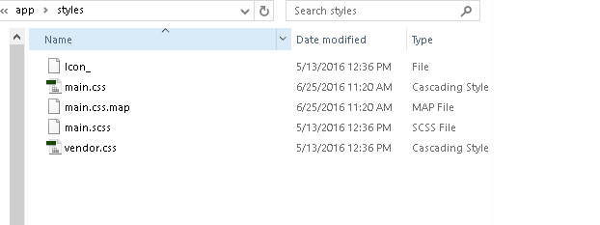

* Copy and change vendor.txt to vendor.css
* Copy file Lato.css and angular-csp.css to app/styles

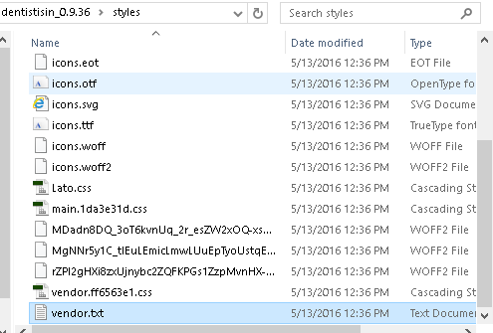

1. Create and setup Gruntfile.js

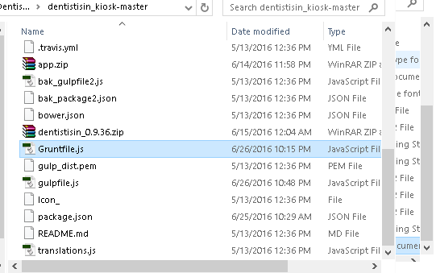

* Define gulp_dist directory

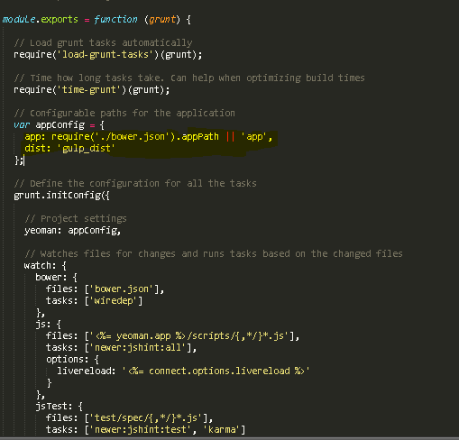

* Copy file to gulp_dist

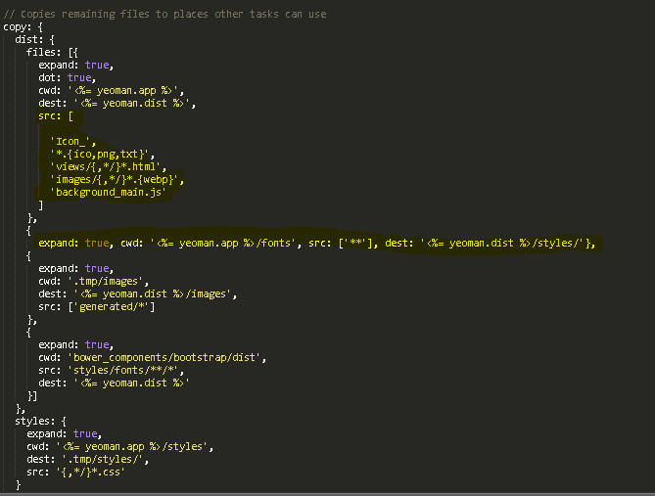

1. Modify gulpfile.js

Insert this code to gulpfile.js

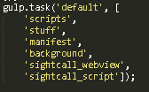

1. Start creating build  
   Run command in Node.js command promt

* Grunt build
* Gulp

1. If you have error “missing templates.js” while gulp build, you have to install this package:

<https://www.npmjs.com/package/gulp-header>

1. Check gulp_dist after build finished

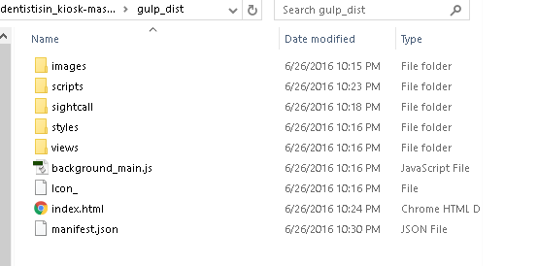

1. Replace manifest.json with manifest.json in dentistisin_0.9.36
2. Change scripts and styles index.html



**How to build Dentistisin web app.**

* Using "meteor-build-client". Refer to link: <https://github.com/frozeman/meteor-build-client>